**DAY 7**

TASK 1:

package com.test.ClassExercise;

import org.openqa.selenium.WebDriver;

import org.openqa.selenium.chrome.ChromeDriver;

import org.openqa.selenium.chrome.ChromeOptions;

import org.testng.Assert;

import org.testng.annotations.Test;

import io.github.bonigarcia.wdm.WebDriverManager;

public class CE1 {

@Test

public void titleCheck() {

WebDriverManager.*chromedriver*().setup();

ChromeOptions co=new ChromeOptions();

co.addArguments("--remote-allow-origins=*");

WebDriver driver=new ChromeDriver(co);

driver.get("https://demo.wpeverest.com/user-registration/guest-registration-form/");

driver.manage().window().maximize();

String actual=driver.getTitle();

String expected="Guest Registration Form – User Registration";

Assert.*assertEquals*(actual,expected);

}

}

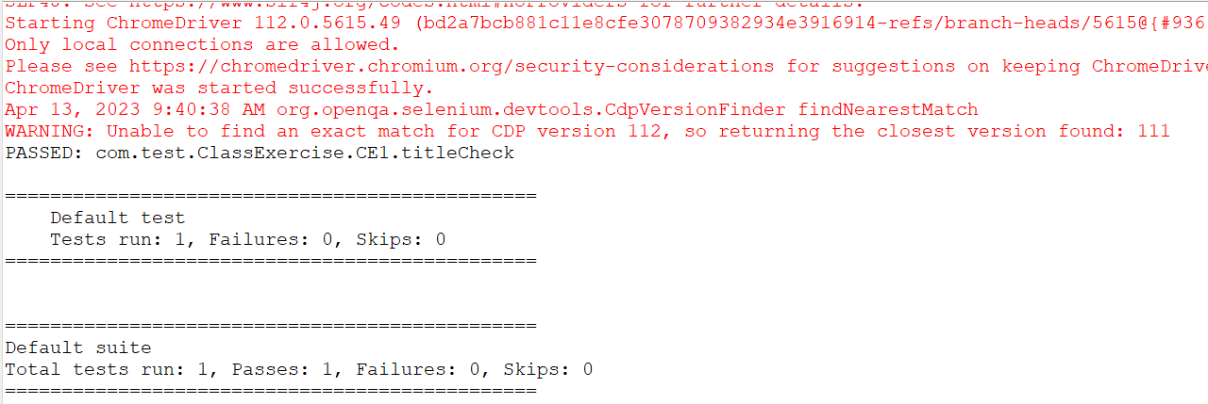

TASK 2:

package com.test.ClassExercise;

import org.testng.Assert;

import org.testng.annotations.Test;

public class CE2 {

@Test(priority=2)

public void add() {

int a=4;

int b=5;

int c=a+b;

int d=9;

System.*out*.println(c);

Assert.*assertEquals*(c,d);

}

@Test(priority=4)

public void subtract() {

int a=10;

int b=5;

int c=a-b;

int d=5;

System.*out*.println(c);

Assert.*assertEquals*(c,d);

}

@Test(priority=3)

public void multiply() {

int a=4;

int b=5;

int c=a*b;

int d=20;

System.*out*.println(c);

Assert.*assertEquals*(c,d);

}

@Test(priority=1)

public void divide() {

int a=10;

int b=2;

int c=a/b;

int d=5;

System.*out*.println(c);

Assert.*assertEquals*(c,d);

}

}

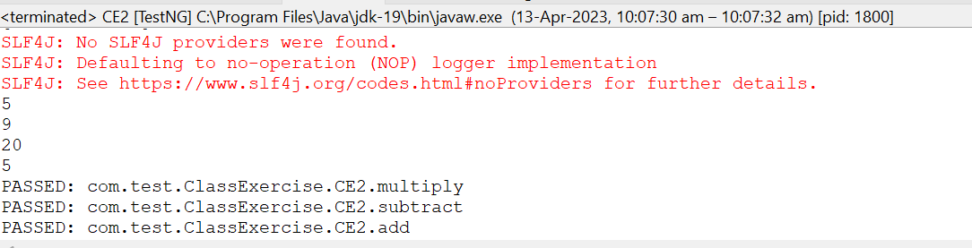

TASK 3:

package com.test.ClassExercise;

import org.testng.annotations.Test;

import io.github.bonigarcia.wdm.WebDriverManager;

import org.testng.annotations.BeforeMethod;

import org.openqa.selenium.By;

import org.openqa.selenium.WebDriver;

import org.openqa.selenium.WebElement;

import org.openqa.selenium.chrome.ChromeDriver;

import org.openqa.selenium.chrome.ChromeOptions;

import org.testng.Assert;

import org.testng.annotations.AfterMethod;

public class CE3 {

WebDriver driver;

@Test

public void max_wid() {

WebElement from=driver.findElement(By.*xpath*("//*[@id=\"app\"]/div[1]/div/div[1]/div/div[2]/div[2]/form/div[1]/div/div[2]/input"));

from.sendKeys("Admin");

WebElement to=driver.findElement(By.*xpath*("//*[@id=\"app\"]/div[1]/div/div[1]/div/div[2]/div[2]/form/div[2]/div/div[2]/input"));

to.sendKeys("admin123");

WebElement submitBtn=driver.findElement(By.*xpath*("//*[@id=\"app\"]/div[1]/div/div[1]/div/div[2]/div[2]/form/div[3]/button"));

submitBtn.click();

String CurrentUrl=driver.getCurrentUrl();

String ExpectedUrl="https://opensource-demo.orangehrmlive.com/web/index.php/dashboard/index";

Assert.*assertEquals*(CurrentUrl, ExpectedUrl);

}

@BeforeMethod

public void beforeMethod() throws InterruptedException {

WebDriverManager.*chromedriver*().setup();

ChromeOptions co=new ChromeOptions();

co.addArguments("--remote-allow-origins=*");

driver=new ChromeDriver(co);

driver.get("https://opensource-demo.orangehrmlive.com/web/index.php/auth/login");

driver.manage().window().maximize();

Thread.*sleep*(3000);

}

@AfterMethod

public void afterMethod() {

driver.close();

}

}

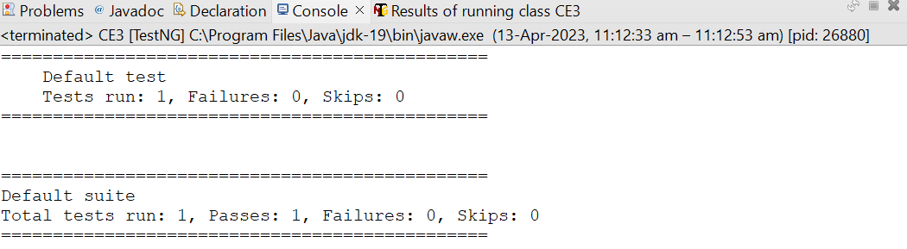

TASK 4:

package com.test.ClassExercise;

import org.testng.annotations.Test;

import io.github.bonigarcia.wdm.WebDriverManager;

import org.openqa.selenium.By;

import org.openqa.selenium.WebDriver;

import org.openqa.selenium.WebElement;

import org.openqa.selenium.chrome.ChromeDriver;

import org.openqa.selenium.chrome.ChromeOptions;

import org.testng.Assert;

public class CE4 {

WebDriver driver;

@Test

public void Login()throws InterruptedException{

WebDriverManager.*chromedriver*().setup();

ChromeOptions co=new ChromeOptions();

co.addArguments("--remote-allow-origins=*");

driver=new ChromeDriver(co);

driver.get("https://opensource-demo.orangehrmlive.com/web/index.php/auth/login");

driver.manage().window().maximize();

Thread.*sleep*(3000);

WebElement from=driver.findElement(By.*xpath*("//*[@id=\"app\"]/div[1]/div/div[1]/div/div[2]/div[2]/form/div[1]/div/div[2]/input"));

from.sendKeys("Admin");

WebElement to=driver.findElement(By.*xpath*("//*[@id=\"app\"]/div[1]/div/div[1]/div/div[2]/div[2]/form/div[2]/div/div[2]/input"));

to.sendKeys("admin123");

WebElement submitBtn=driver.findElement(By.*xpath*("//*[@id=\"app\"]/div[1]/div/div[1]/div/div[2]/div[2]/form/div[3]/button"));

submitBtn.click();

String CurrentUrl=driver.getCurrentUrl();

String ExpectedUrl="https://opensource-demo.orangehrmlive.com/web/index.php/dashboard/index";

System.*out*.println("Login successful");

Assert.*assertEquals*(CurrentUrl, ExpectedUrl);

}

@Test(dependsOnMethods={"Login"})

public void Logout() throws InterruptedException{

Thread.*sleep*(3000);

WebElement submitBtn=driver.findElement(By.*xpath*("//*[@id=\"app\"]/div[1]/div[1]/header/div[1]/div[2]/ul/li/span"));

submitBtn.click();

WebElement submitBtm=driver.findElement(By.*xpath*("//*[@id=\"app\"]/div[1]/div[1]/header/div[1]/div[2]/ul/li/ul/li[4]/a"));

submitBtm.click();

String CurtUrl=driver.getCurrentUrl();

String ExpectUrl="https://opensource-demo.orangehrmlive.com/web/index.php/auth/login";

System.*out*.println("Logout");

Assert.*assertEquals*(CurtUrl, ExpectUrl);

}

}

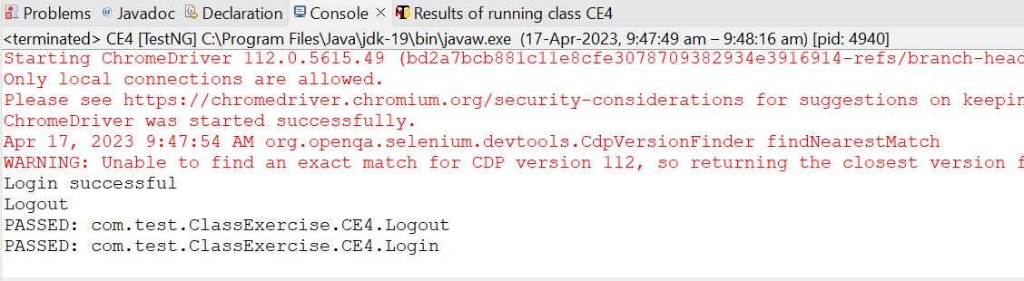

TASK 5:

package com.Demo.Demo;

import org.testng.annotations.Test;

import io.github.bonigarcia.wdm.WebDriverManager;

import org.testng.annotations.BeforeMethod;

import java.util.concurrent.TimeUnit;

import org.openqa.selenium.By;

import org.openqa.selenium.WebDriver;

import org.openqa.selenium.chrome.ChromeDriver;

import org.openqa.selenium.chrome.ChromeOptions;

import org.testng.Assert;

import org.testng.annotations.AfterMethod;

public class d75

{

WebDriver d;

@Test(groups=&quot;Smoke Test&quot;)

public void t1()

{

String eurl=&quot;https://www.godaddy.com/en-in&quot;;

String curl=d.getCurrentUrl();

Assert.assertEquals(eurl,curl);

String etitle=&quot;Domain Names, Websites, Hosting &amp; Online Marketing Tools - GoDaddy IN&quot;;

String ctitle=d.getTitle();

Assert.assertEquals(etitle,ctitle);

}

@Test(groups=&quot;Regression Test&quot;)

public void t2()

{

d.manage().timeouts().implicitlyWait(10,TimeUnit.SECONDS);

d.findElement(By.xpath(&quot;//*[@id=\&quot;id-631b049a-e9c0-4d24-8710-

c504745206dd\&quot;]/div[2]/div[1]/ul/li[1]/button&quot;)).click();

d.findElement(By.xpath(&quot;//*[@id=\&quot;id-631b049a-e9c0-4d24-8710-

c504745206dd\&quot;]/div[2]/div[1]/ul/li[1]/div/div[2]/div[1]/ul/li[2]/a&quot;)).click();

}

@Test(groups=&quot;Regression Test&quot;)

public void t3()

{

d.manage().timeouts().implicitlyWait(10,TimeUnit.SECONDS);

d.findElement(By.xpath(&quot;//*[@id=\&quot;id-631b049a-e9c0-4d24-8710-

c504745206dd\&quot;]/div[2]/div[1]/ul/li[1]/button&quot;)).click();

d.findElement(By.xpath(&quot;//*[@id=\&quot;id-631b049a-e9c0-4d24-8710-

c504745206dd\&quot;]/div[2]/div[1]/ul/li[1]/div/div[2]/div[1]/ul/li[2]/a&quot;)).click();

String ctitle=d.getTitle();

String etitle=&quot;GoDaddy Domain Search - Buy and Register Available Domain Names&quot;;

System.out.println(ctitle);

Assert.assertEquals(etitle, ctitle);

}

@BeforeMethod

public void beforeMethod()

{

ChromeOptions co=new ChromeOptions();

co.addArguments(&quot;--remote-allow-origins=*&quot;);

WebDriverManager.chromedriver().setup();

d=new ChromeDriver(co);

d.get(&quot;https://www.godaddy.com/en-in&quot;);

d.manage().window().maximize();

}

@AfterMethod

public void afterMethod()

{

d.close();

}

}

